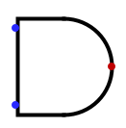 | AND = A⋅B
 | 1 | 0 | 0
 | 0 | 1 | 0
 | 1 | 0 | 0
 | 1 | 1 | 1
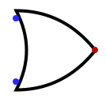 | OR = A+B
 | 0 | 0 | 0
 | 1 | 0 | 1
 | 0 | 1 | 1
 | 1 | 1 | 1
 | NOT = !A
 | 0 |  | 1
 | 1 |  | 0
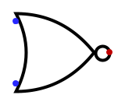 | NOR = A↓B
 | 0 | 0 | 1
 | 1 | 0 | 0
 | 0 | 1 | 0
 | 1 | 1 | 0
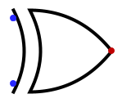  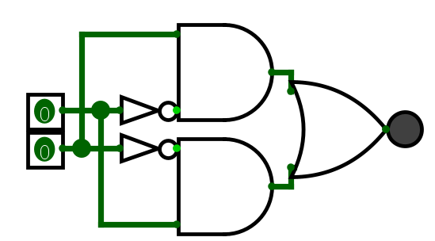 | XOR = A⊕B  (A⋅!B)+(!A⋅B)
 | 0 | 0 | 0
 | 1 | 0 | 1
 | 0 | 1 | 1
 | 1 | 1 | 0
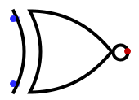  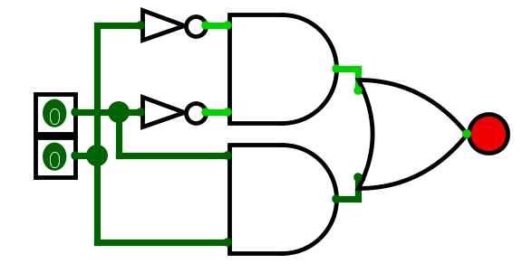 | XNOR = A⊙B  (A⋅B)+(!A⋅!B)
 | 0 | 0 | 1
 | 1 | 0 | 0
 | 0 | 1 | 0
 | 1 | 1 | 1

